Sunday | Monday | Tuesday | Wednesday | Thursday | Friday | Saturday
 |  | 1  Write upper and lower case Aa 5 times and draw and label picture that begins with Aa. | 2  Complete page 39 Lesson 2-1 in Math Packet. | 3  Write upper and lower case Bb 5 times and draw and label picture that begins with Bb. | 4  Practice the Sign of the Cross. | 5
6 | 7  Complete page 43 Lesson 2-2 in Math Packet. | 8  Write upper and lower case Cc 5 times and draw and label picture that begins with Cc. | 9  Complete page 47 Lesson 2-3 in Math Packet. | 10  Write upper and lower case Dd 5 times and draw and label picture that begins with Dd. | 11  Practice the Sign of the Cross. | 12
13 | 14  Complete page 53 Lesson 2-4 in Math Packet. | 15  Write upper and lower case Ee 5 times and draw and label picture that begins with Ee. | 16  Complete page 57 Lesson 2-5 in Math Packet. | 17  Write upper and lower case Ff 5 times and draw and label picture that begins with F. | 18  No School! | 19
20 | 21  Practice writing your first and last name 3 times. REMEMBER only the first letters should be upper case! | 22  Write upper and lower case Gg 5 times and draw and label picture that begins with Gg. | 23  Complete page 61 Lesson 2-6 in Math Packet. | 24  Write upper and lower case Hh 5 times and draw and label picture that begins with Hh. | 25  Practice the Sign of the Cross. | 26
27 | 28  Practice writing your first and last name 3 times. REMEMBER only the first letters should be upper case! | 29  Complete page 67 Problem Solving in Math Packet. | 30  Write and draw about your Halloween costume. | 31  Have fun trick or treating! 😊
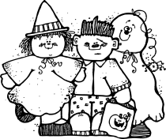
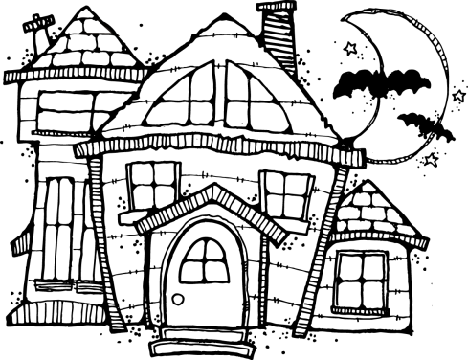
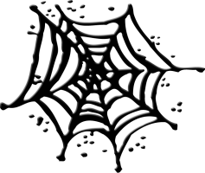
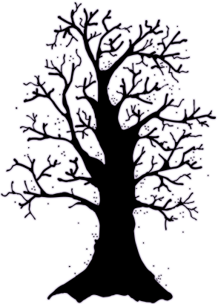
October
Name___________________

